**SBRT Lung Prep**

**RayStation Doctor**

1. Import from Storage SCP
   * Import new patient.

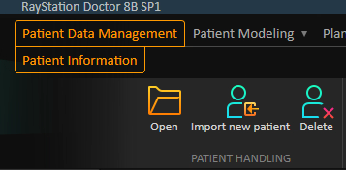

* + Import CTs, RTStruct, and RTPlan (everything) from Storage SCP.

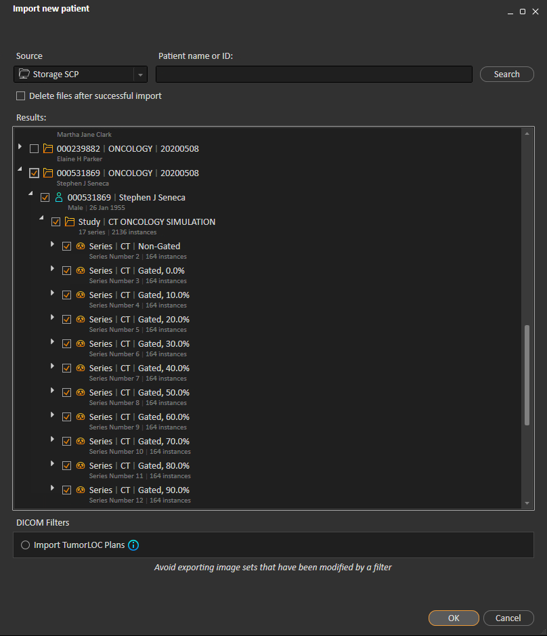

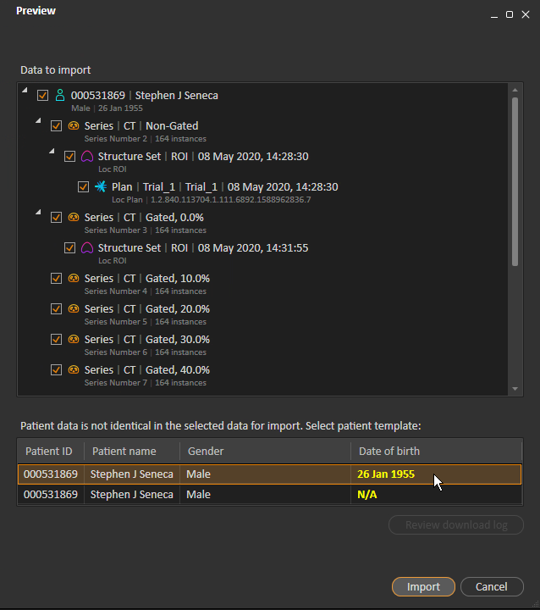

Ignore errors like the following:

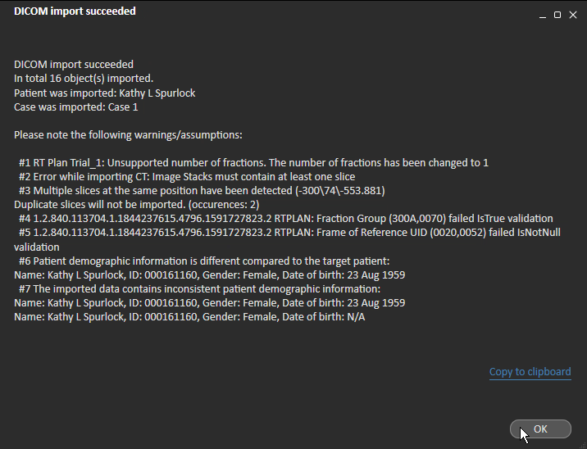

1. Run script.

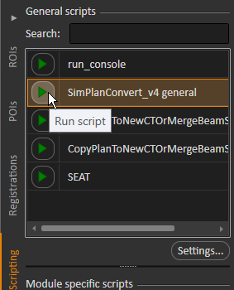

1. In Plan Design, Laser Export, lock shift

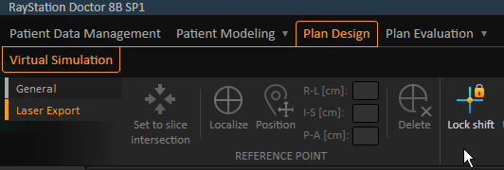

1. Save patient with Ctrl + S.
2. Close RayStation Doctor.

**RayStation Planning**

1. Open the patient.
2. Rename the “Trial_1” plan to “Initial Sim.”

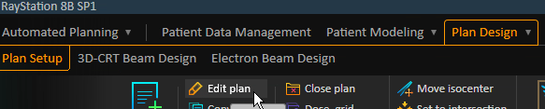

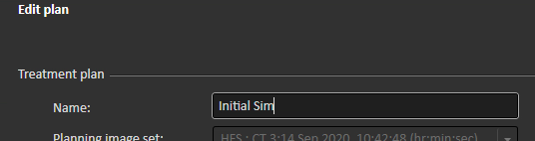

1. If the patient has gated images, run script **CreateGatedGroup** to create a 4DCT image set.

*If the script is not available*, do the following:

* + Create 4DCT group…

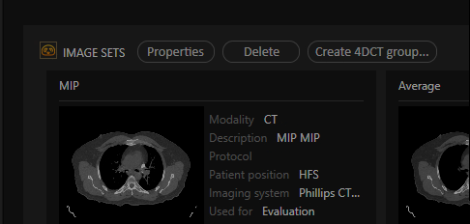

* + Name the image set “4D Phases <M/D/YYYY>” and add all the gated scans to the group.

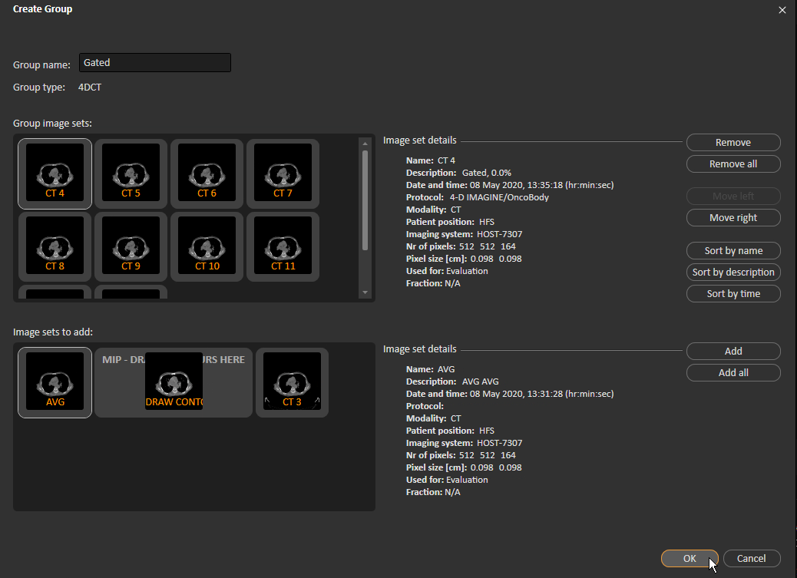

1. In Patient Data Management, check for a MIP and an AVG image set. If either is missing, create it. If either is inappropriately cut off, delete it

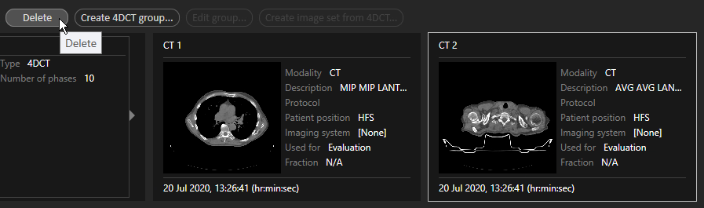

and recreate it:

* MIP:

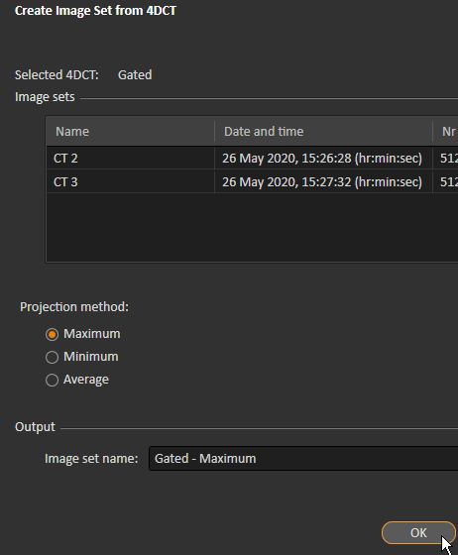

* AVG:

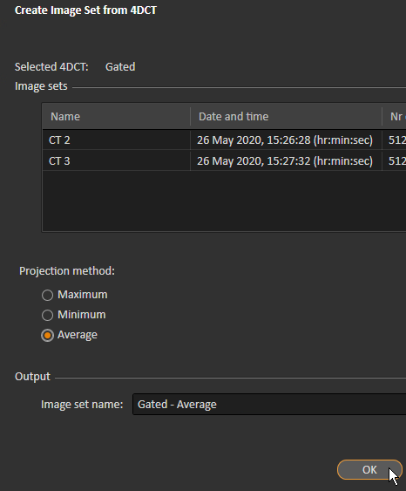

1. In Patient Data Management, prepare CT images for planning.
   * Select the MIP and click *Properties*.

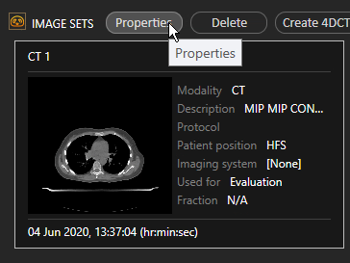

* + Rename the MIP to “MIP – DRAW CONTOURS HERE <M/D/YYYY>” and select “Philips CT” or “HOST…” for the source.

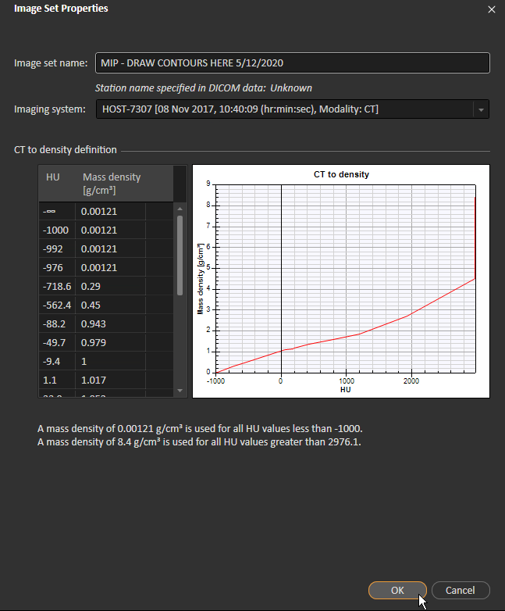

Ignore the following warning:

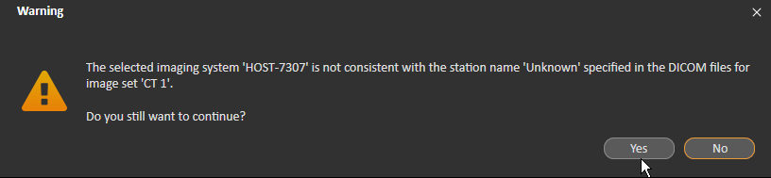

* + Select the AVG and click *Properties*.

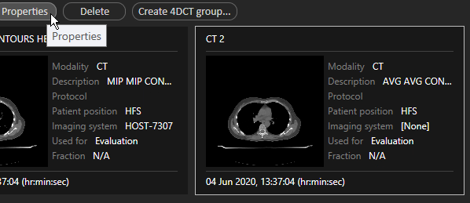

* + Rename the average to “AVG <M/D/YYYY>” and select “Philips CT” or “HOST…” for the source.

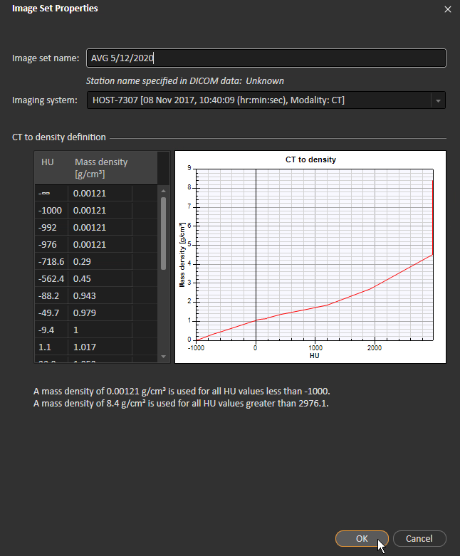

* + Select the non-gated CT and click *Properties*.

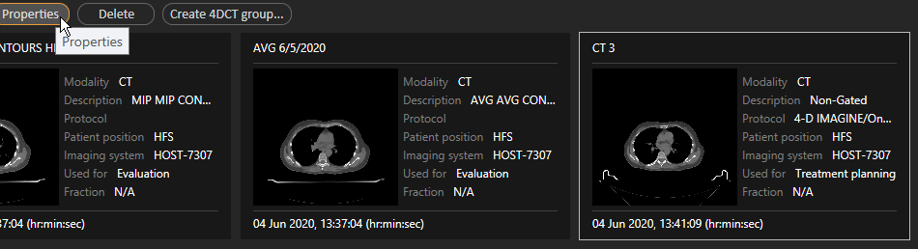

* + Rename the non-gated CT to “Non-Gated <M/D/YYYY>” and select “Philips CT” or “HOST…” for the source.

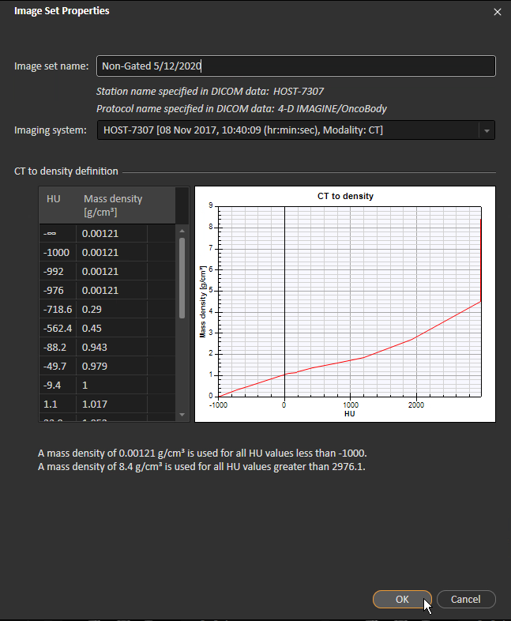

1. In Patient Modeling, Deformable Registration, create a Deformable between 3D and average scans.
   * 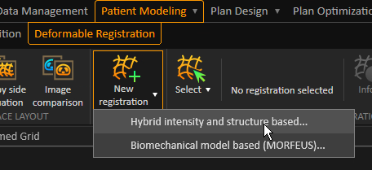
   * The reference is the 3D (non-gated) image, and the target is the average.

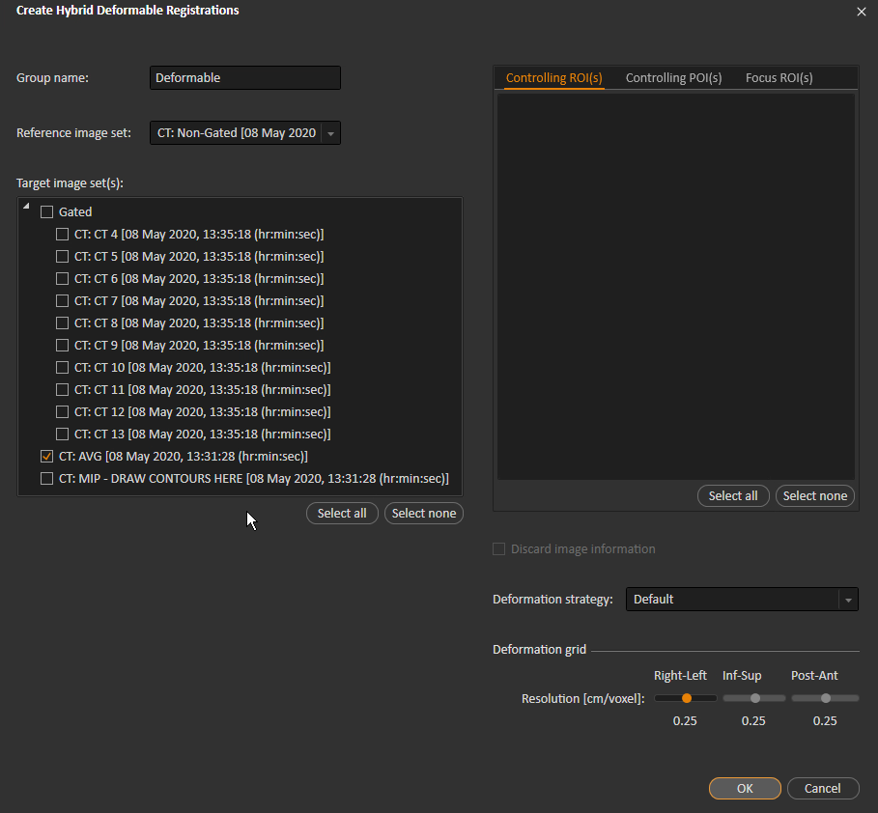

1. Deform POIs from 3D to Average
   * 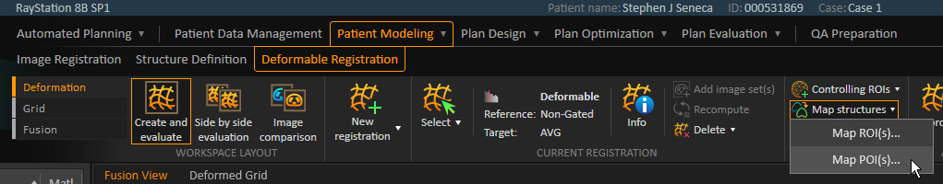
   * Create New Geometry from the localization point and initial isocenter.

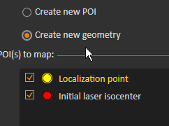

1. Use the appropriate structure template.
   * 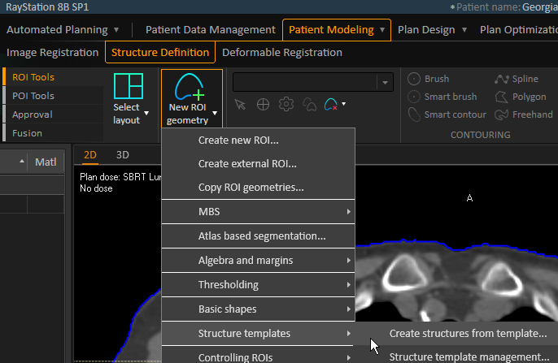
   * Choose the appropriate template and select *Empty geometries*.

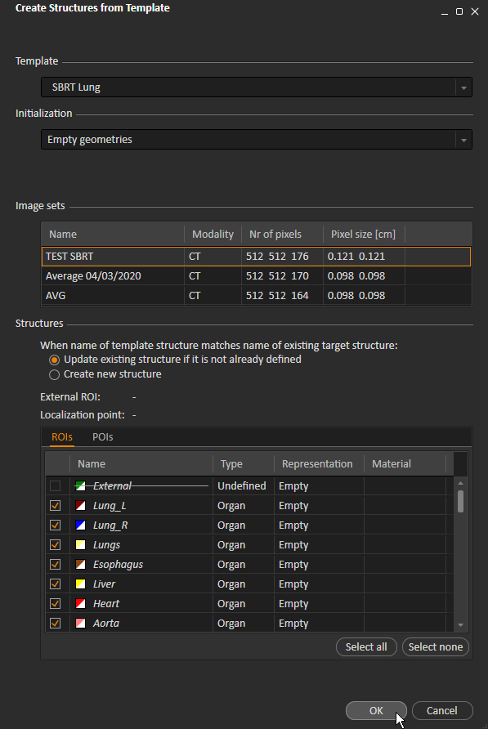

* + It is okay that the template is not approved.

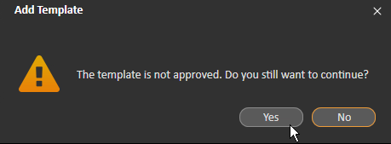

1. Save the patient.
2. Create a new plan for QED.
   * In Plan Design > Plan Setup, click *New plan*.

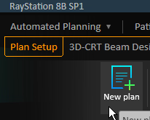

* + Fill out the necessary fields. The planning image is the average.

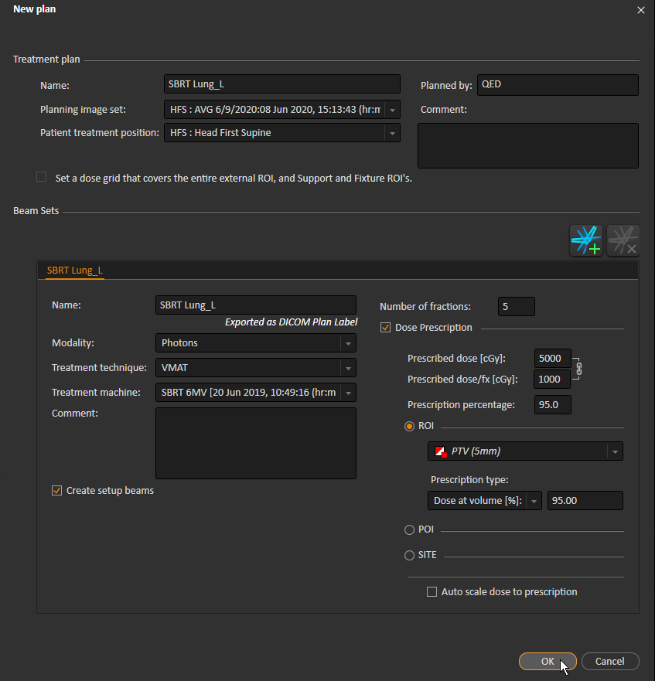

1. Set the dose grid to 2 cm.

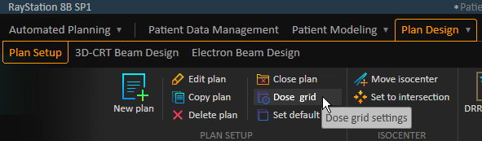

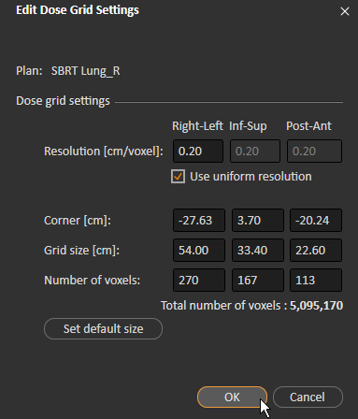

1. Update derived ROIs. Derived ROIs have a white circle.



Click each derived ROI. If the ROI has a red square, it needs updating.

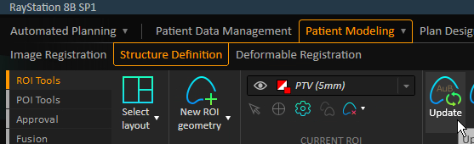

Ignore the following warning:

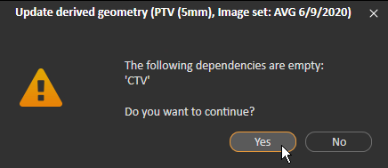

1. Change the color table to CRMC Standard Dose Colorwash.
   * Right-click an image and select *Edit color table…*

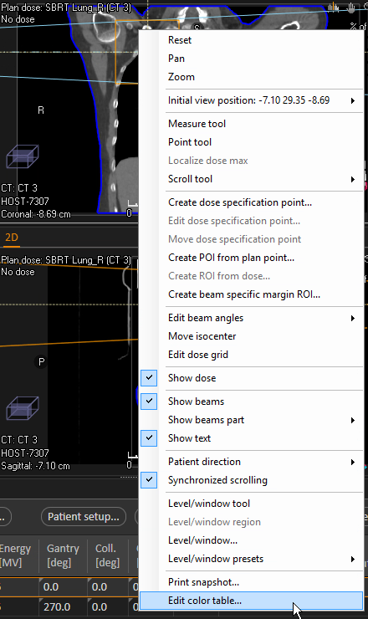

* + Select CRMC Standard Dose Colorwash.

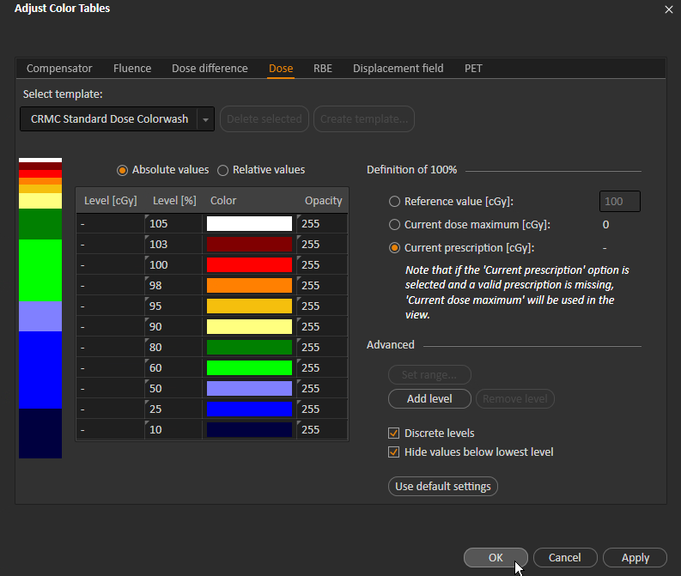

1. Under Plan Design, Plan Setup, add beams.

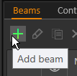

The beam numbers should be unique over all treatments in the patient’s history. (Check D and I in MOSAIQ for previous treatments.) The SBRT Lung plan should have two beams (numbers and names will be different if patient has been treated before):

|  |  |
| --- | --- |
| **No.** | **Name** |
| 1 | ARC1 |
| 2 | ARC2 |

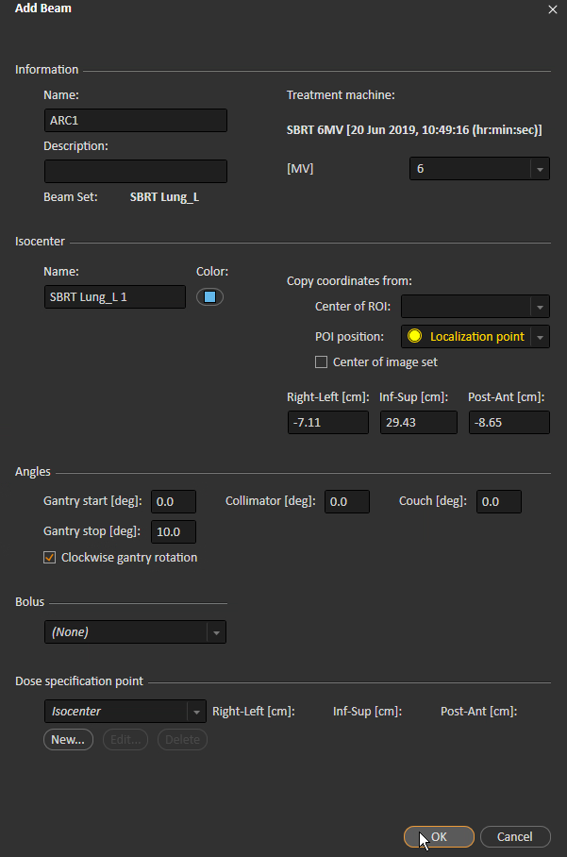

Note that the gantry stop is just something obviously incorrect so that QED knows to change the beams.

You may copy the first beam to create the second:

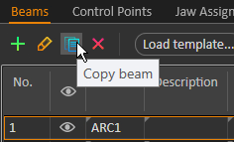

1. Add geometry for external ROI.

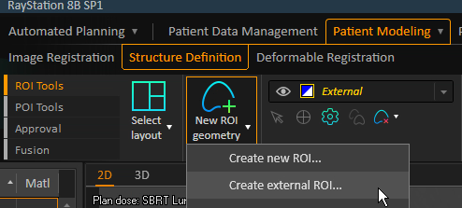

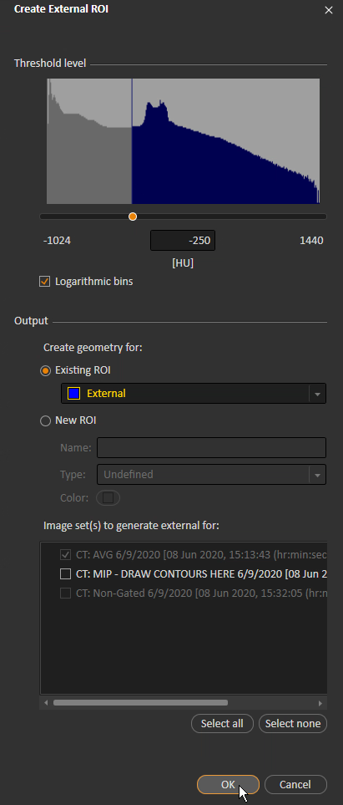

1. Examine the External ROI. Expand if necessary.

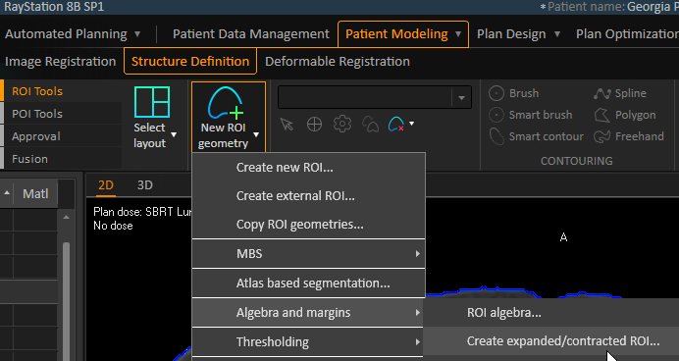

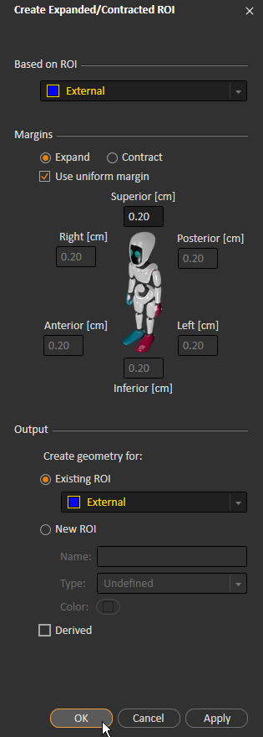

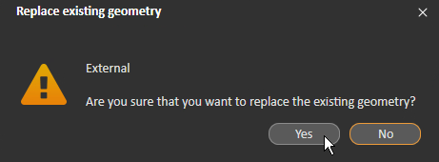

1. Copy the External ROI into Skin.

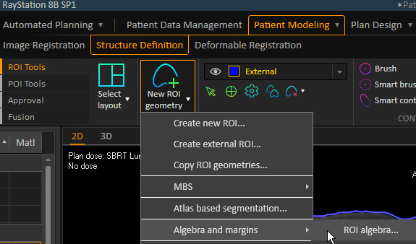

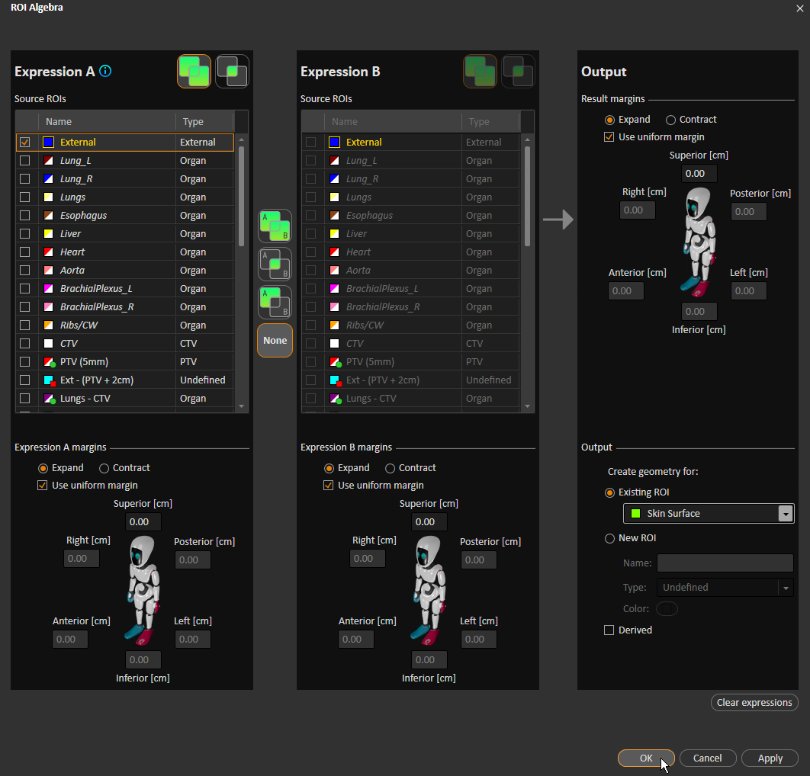

1. Right-click and change leveling to Lung so you can see the table. You may also need to zoom out.
2. Add and position couch.
   * Add couch structures from template. Select “Align image centers” for Initialization.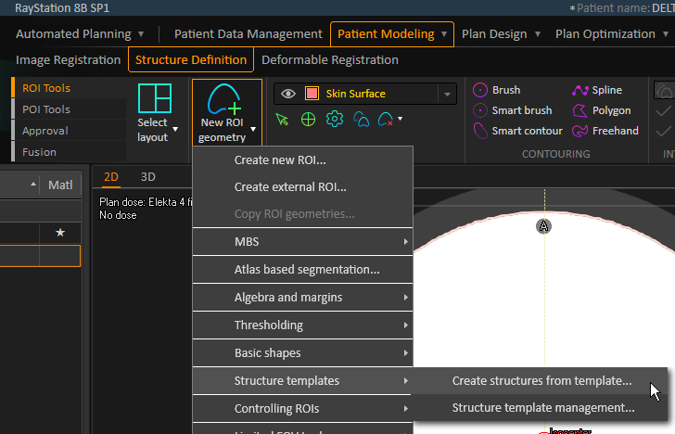
   * 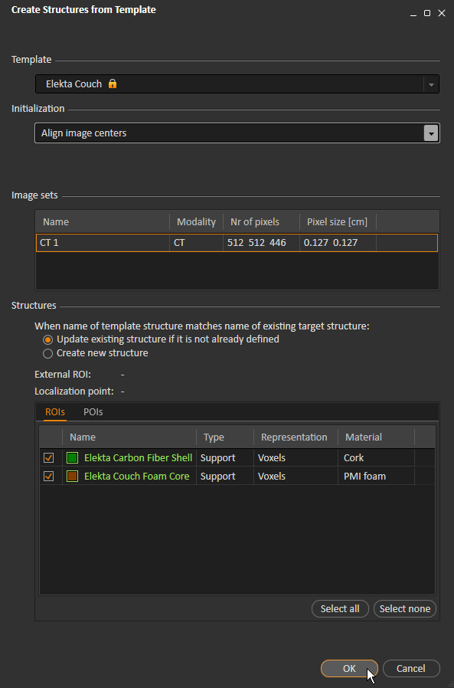
   * Select (Ctrl + click) both components of the couch.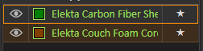

You should see the following:

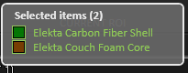

* + Translate the couch to align with the table.

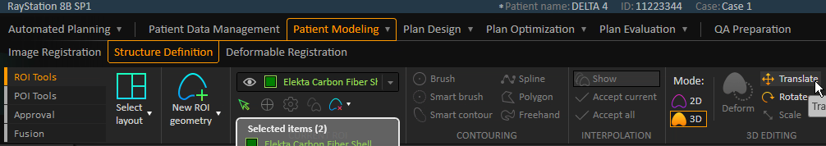

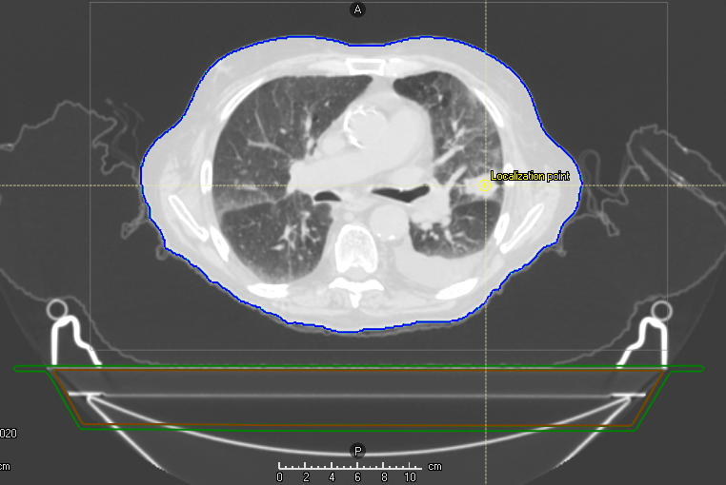

1. Expand the dose grid if it is smaller than the image.
   * In Plan Design > Plan Setup, right-click and select *Edit dose grid.*

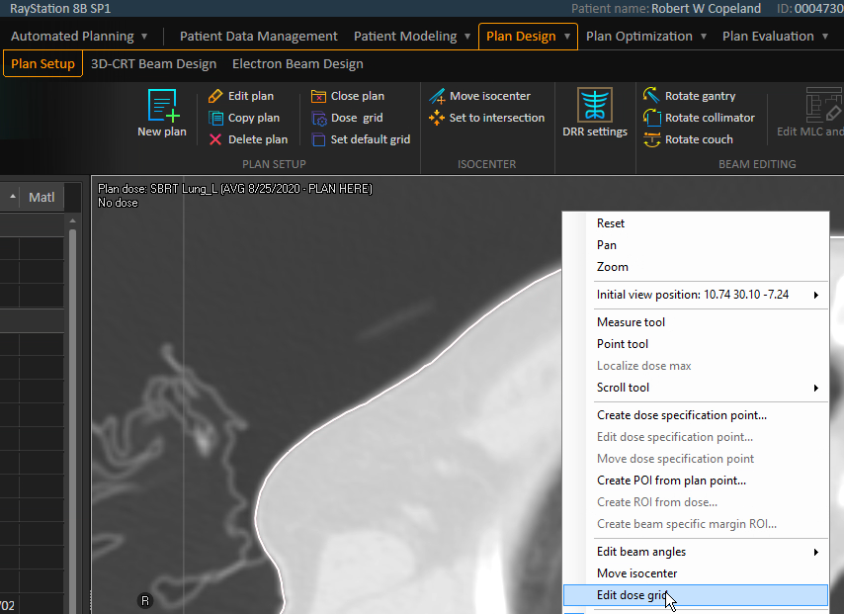

* + Click and drag the white dots on each side to resize the grid. Ensure that the grid extends posteriorly to the couch and that it is nearly as wide as the image.

1. Scroll in the image views until the crosshair is on the localization point in all three views.
2. Add a box ROI.
   * Right-click and select the Measure tool.

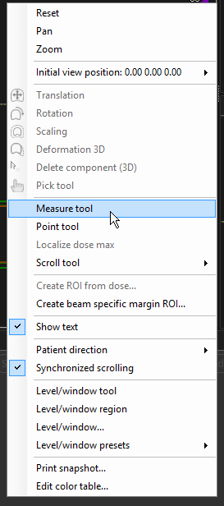

* + Measure R-L in the transverse view. Leave a little room on both sides so that the box ROI will not extend outside of the image, and make sure that your measurement is not wider than the couch. Write down your measurement.

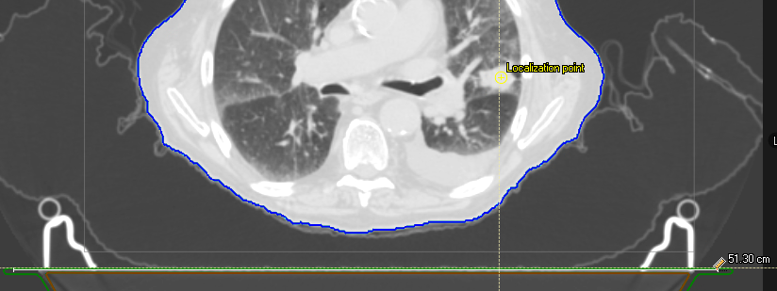

* + Measure P-A in the transverse view. Measure from the couch to about the top of the Vaclok.

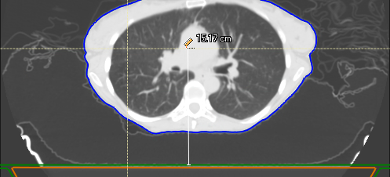

* + Measure I-S in the sagittal view. U

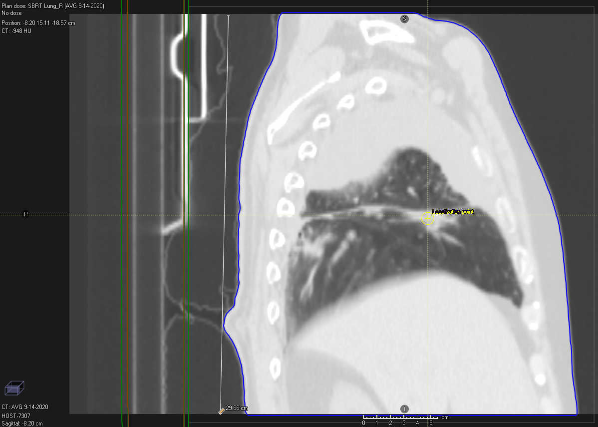

* + Add the box ROI.

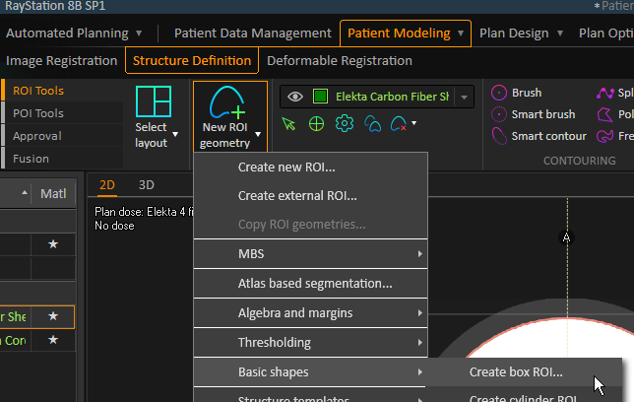

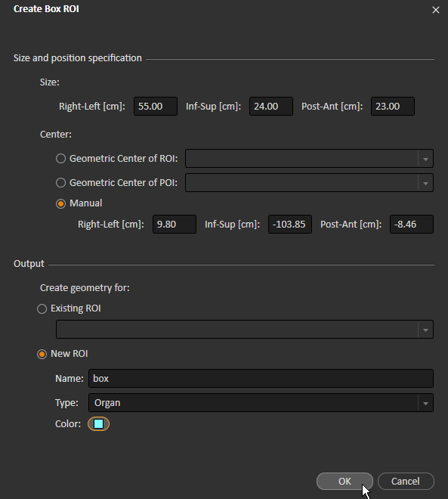

* + Translate the box ROI so that it barely overlaps the couch.

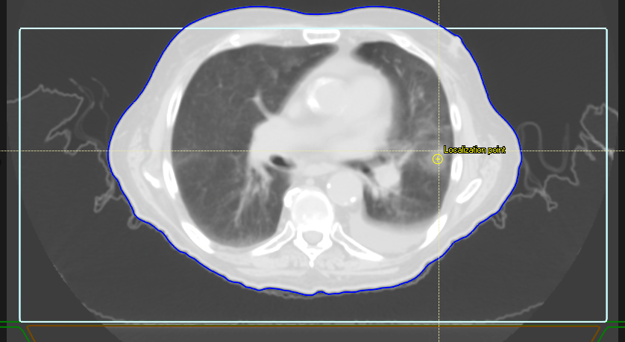

1. Add box to external.
   * 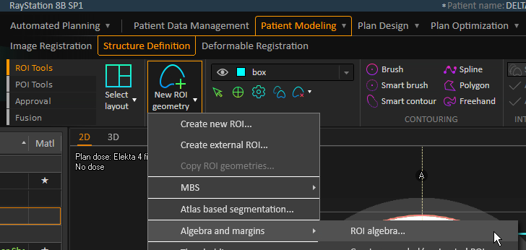
   * Under *Expression A*, select *External* and *box*. Select *External* as the existing ROI under *Output*, and uncheck *Derived*.

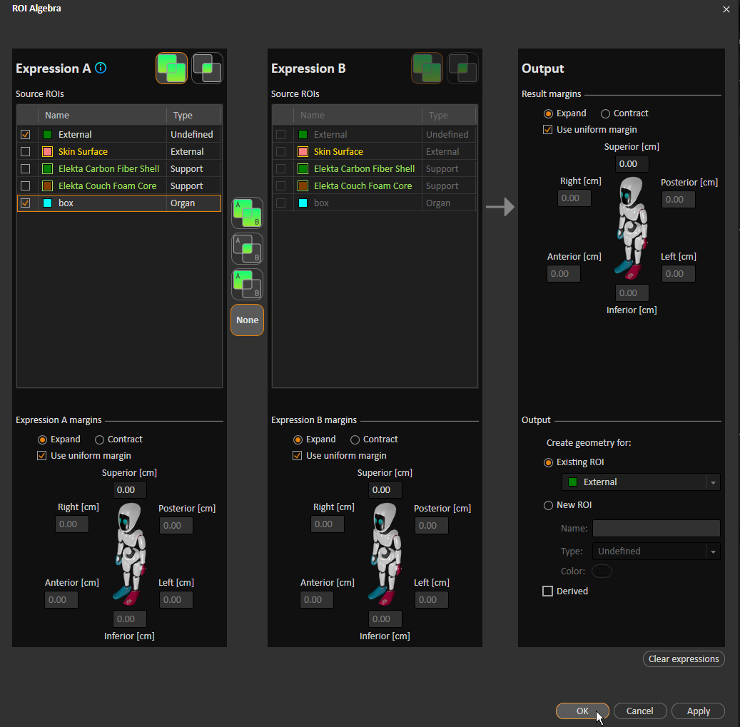

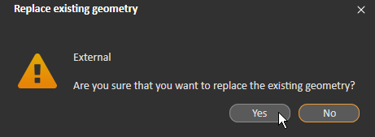

1. Remove couch. You may do this in one of two ways.
   * Option 1: ROI algebra

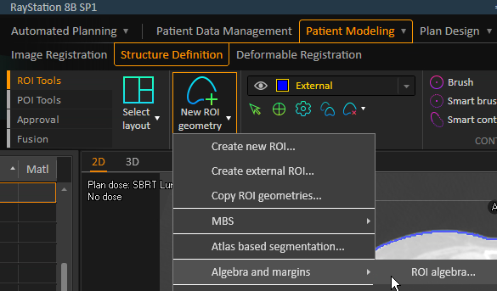

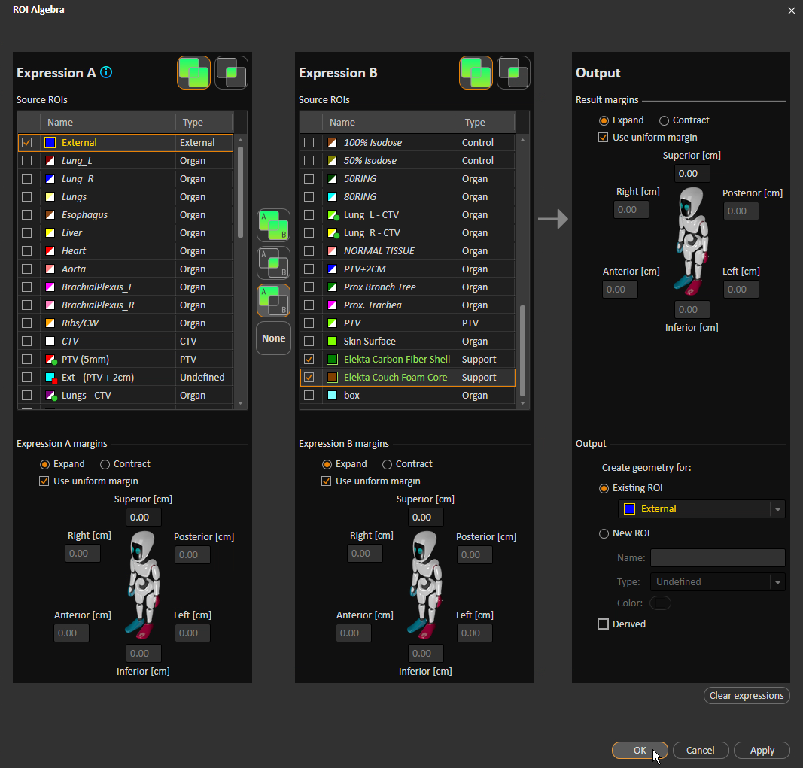

* + Option 2: *Couch removal* tool
    1. Move in the coronal view until you overlap the edge of the couch in the transverse view.

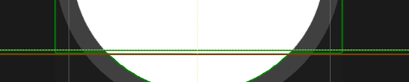

* + 1. Ensure that *External* ROI is selected, and remove couch.



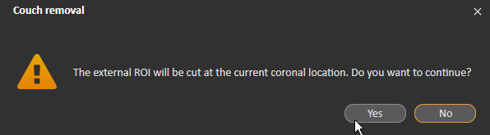

1. Load the SBRT Clinical Goals Template.

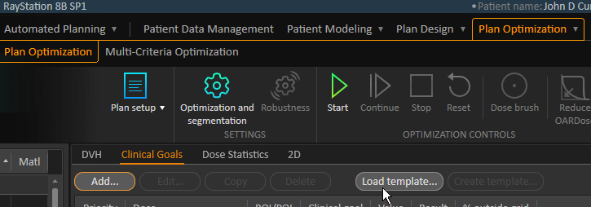

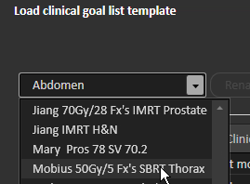

1. Save the patient.
2. Add the patient to the doctor’s board with a due date of tomorrow.

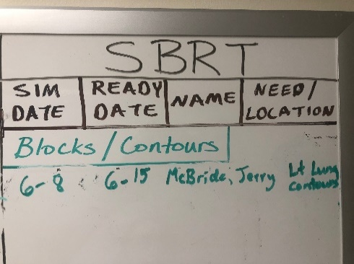

1. Add the patient to the Google Sheet.
2. Close the patient in RayStation.
3. After MD draws targets, check them.
   * The targets must be drawn on the MIP.
   * The target should be the CTV, not the PTV.
   * The PTV (PTV^5mm) should be updated since it is a derived structure that depends on the CTV.
4. After MD draws targets, email QED that patient #<MRN> is ready for an SBRT plan.